Turiba University
AJWIN JOJU VENNATTUPARAMBIL

FOUR EYE METHOD

PROFESSIONAL BACHELOR THESIS

Study Programme: Computer Systems

Author: AJWIN JOJU VENNATTUPAAMBIL

Thesis Advisor: Janis Peksa

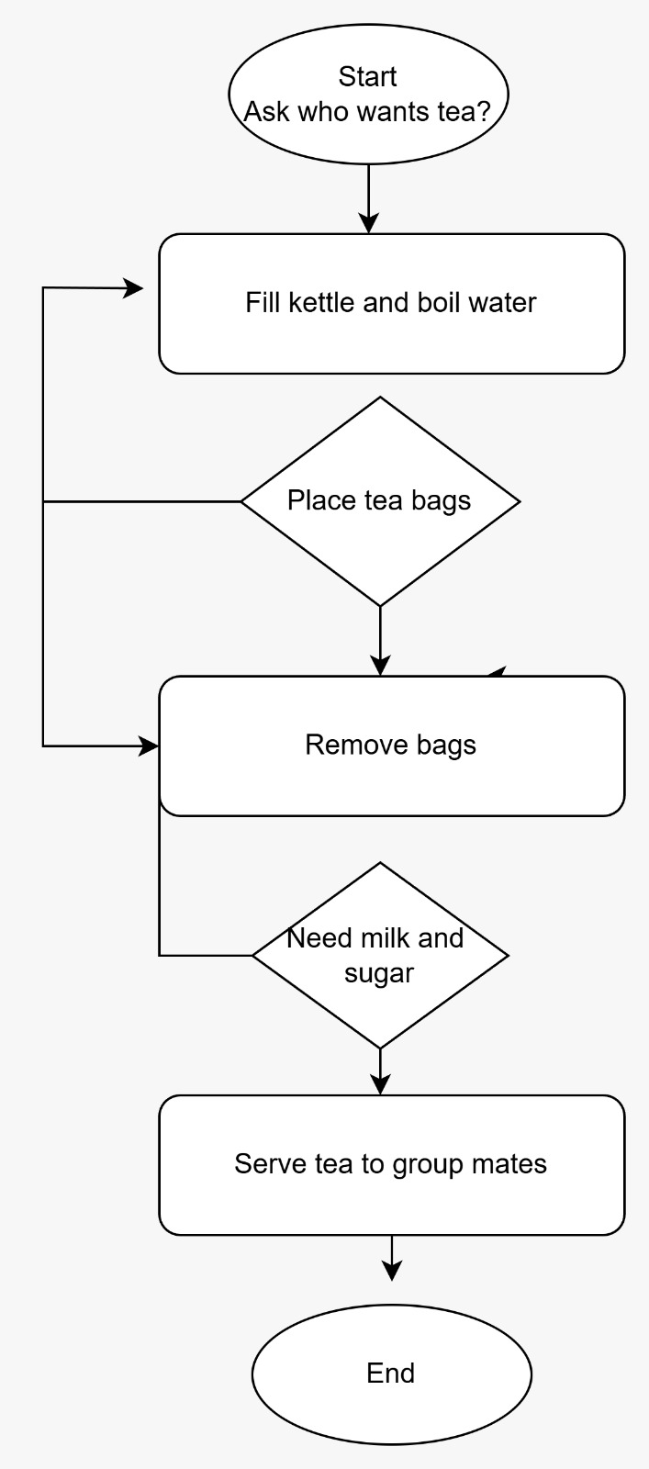
REPORT ON FLOW CHART

CLASSMATE : VIVEK VINOD

FLOWCHART : TEA TO GROUPMATE

Pros

1. Improved Accuracy

Reduces errors such as wrong drink, wrong ingredients, or forgotten preferences.

2. Enhanced Safety

Especially helpful in processes involving hot liquids, ensuring vetting/security steps are followed.

3. Quality Assurance

Ensures consistency in preparation (strength, sweetness, temperature).

4. Accountability

Shared responsibility reduces the likelihood of mistakes or misconduct.

5. Better Customer Satisfaction

Recipients receive properly prepared drinks matched to their request.

Cons

1. Slower Process

Requiring two people at each stage increases preparation time.

2. Higher Labor Requirement

Needs at least two people; inefficient for small teams.

3. Potential Bottlenecks

If either person is delayed, the entire workflow pauses.

4. Over-Control for Simple Tasks

Serving tea/coffee is low-risk; adding formal checks may feel excessive or bureaucratic.

5. Dependency Issues

One person cannot complete the task alone even if capable.

